Wincanton
iSupplier Portal Quick Guide

Version: V1.0

Published date 05/11/18

Table of Contents
1- Review Purchase Order Requests 3
2- View Receipts 7
3- View Returns 10
4- Submitting Invoices by Post 13
5- Invoicing and Payments 14

Review Purchase Order Requests

Purchase orders for goods or services will be sent to you by email, you will also be able to view the order electronically through the iSupplier Portal. Wincanton operate a strict “No Po No Pay” policy with very few exceptions (utility bills for example). As such, all invoices must quote a valid Purchase Order number and match the order in terms of price and value to enable the invoice to be matched and processed for payment. If a Purchase Order number is not quoted or quoted incorrectly, then the invoice will be rejected back to you asking for this to be quoted in full.

To ensure swift payment, it is important to ensure the order contains all lines that will appear on your invoice, as without this the invoice will be queried with the Wincanton site. If you are in doubt, speak with the requisitioner/order raiser who will be able to amend the order in advance of you invoicing to ensure accurate reflection of what they have asked you to provide. Their details will be displayed on the PO.

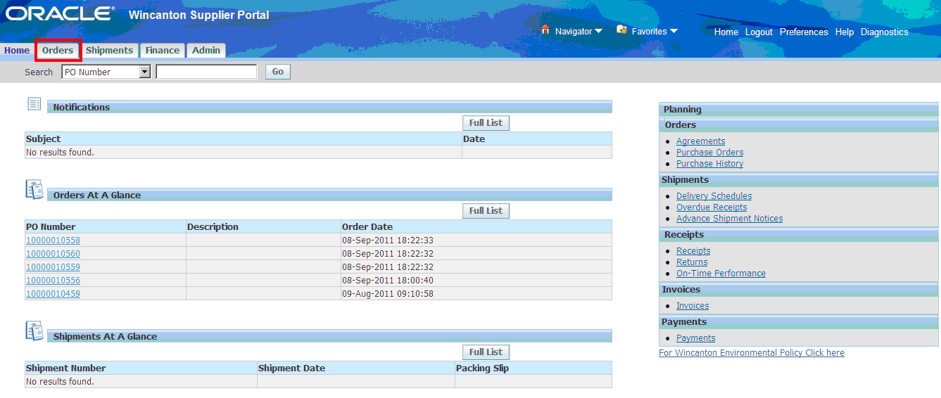
The following steps detail the Purchase Order screens that you will see and respond to.

Step | Action
1. | From the iSupplier Homepage,  Click to view and action orders.

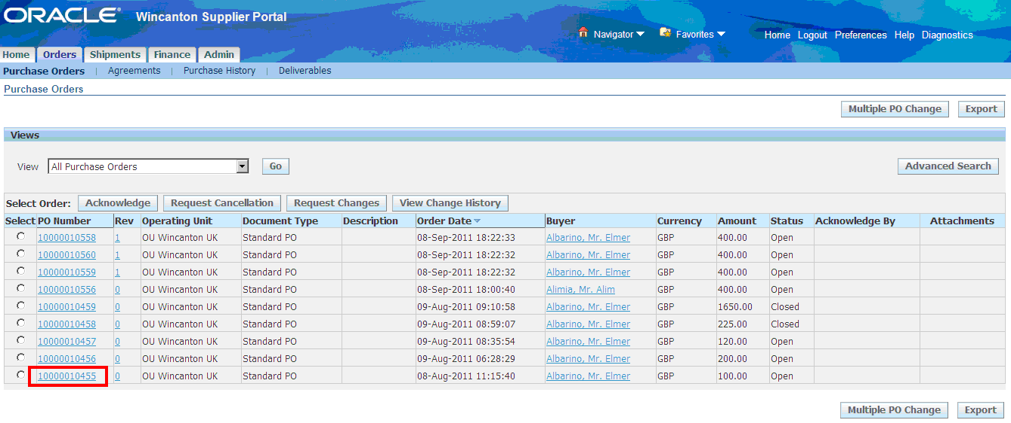
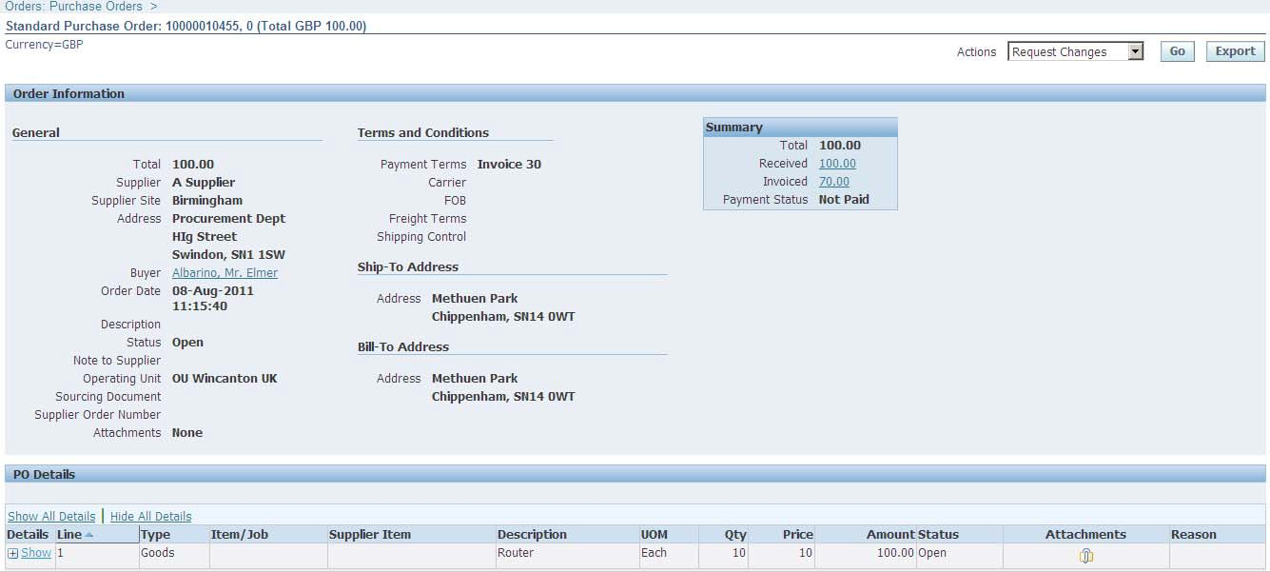
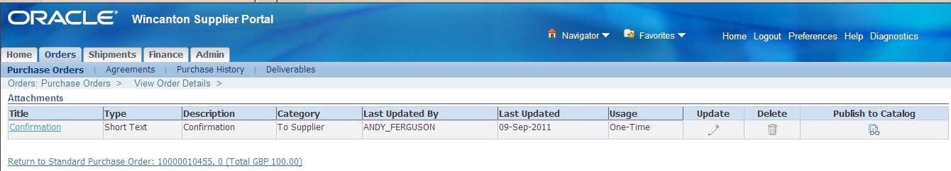

Step | Action
2. | Select the required PO Number by clicking on the relevant Hyperlink

Step | Action
3. | Review selected Purchase Order (including any Attachments)

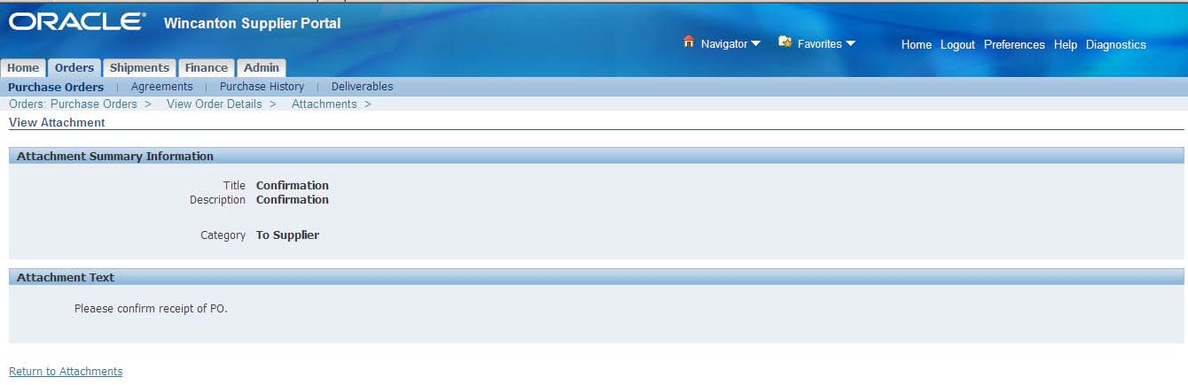
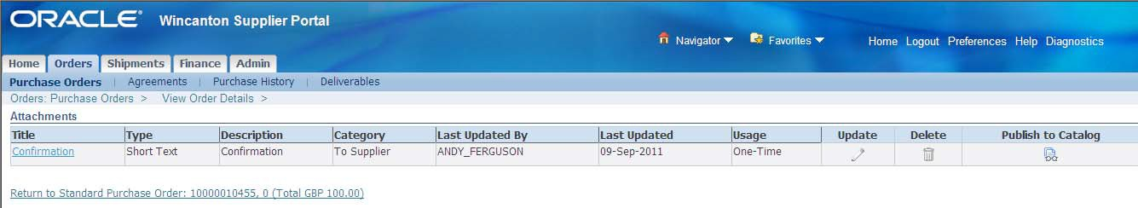
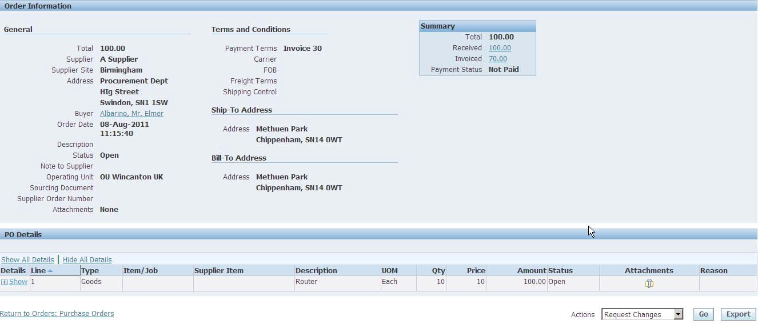
Step | Action
4. | Click | to open attachment

Step | Action
5. | Review attachment details
6. | Click

Step | Action
7. | Click

Step | Action
8. | Click

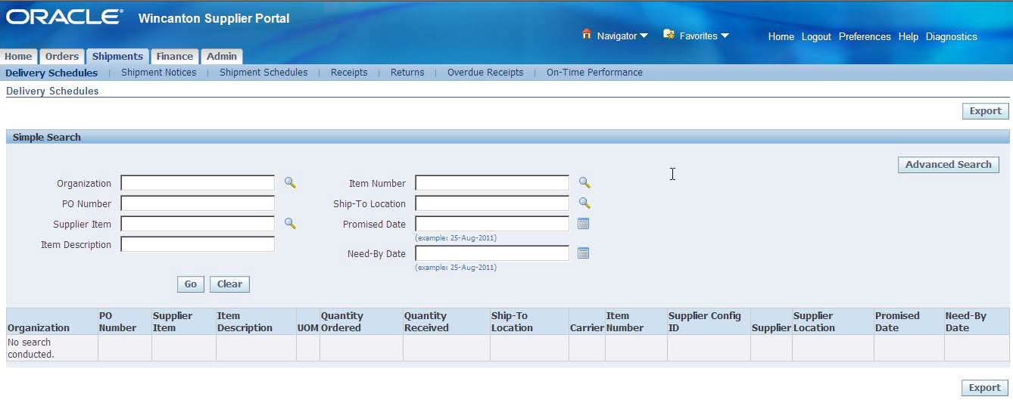

View Receipts

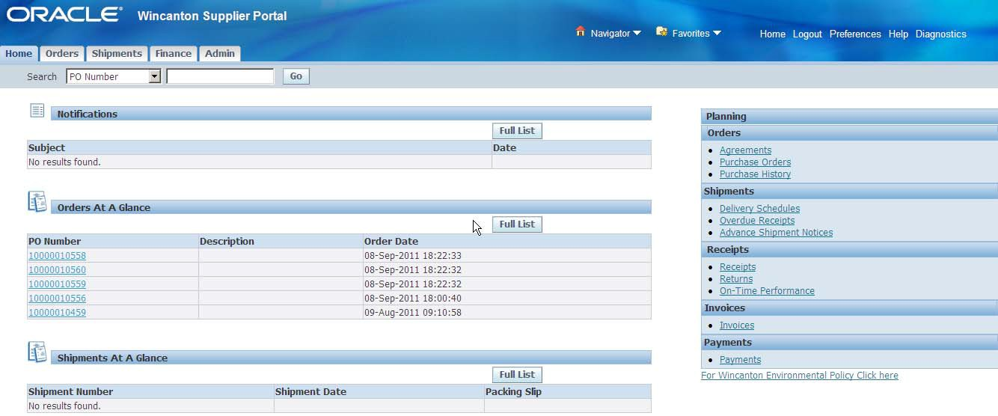
The Receipts web page permits you to explore a historical view of all receipts that have been recorded for your goods or services delivered to Wincanton. In Wincanton’s order and invoicing process, an invoice will not be paid until it has been receipted by the requisitioner/order raiser, as the receipt determines Wincanton are satisfied the goods/services have been delivered and can be paid for. In effect, it is an “okay to pay”.

Step | Action
1. | From the iSupplier Homepage, Click

Step | Action
2. | Click

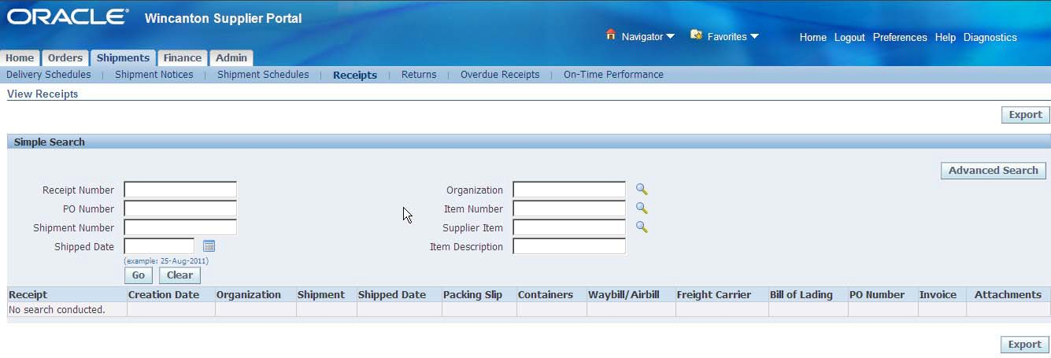
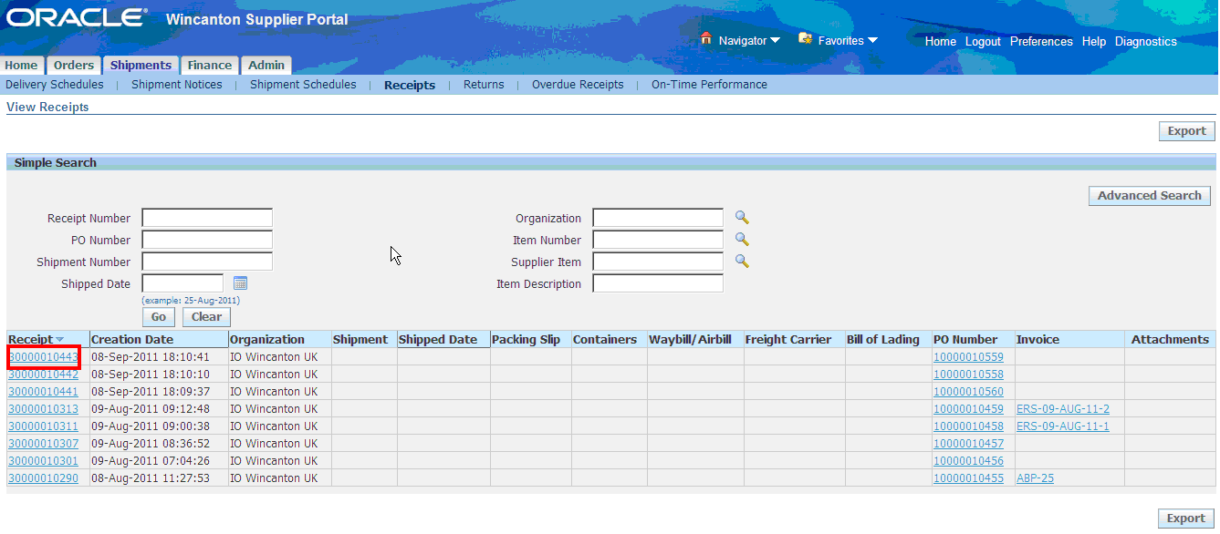
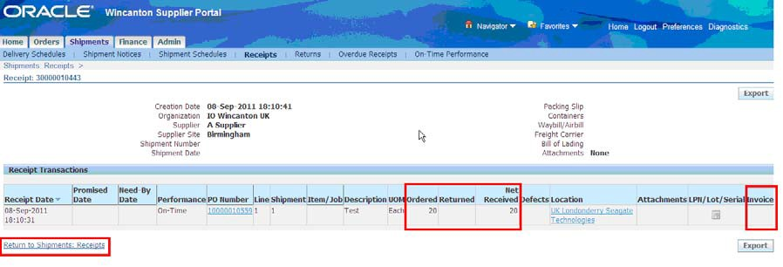

Step | Action
3. | Enter Search Criteria
4. | Click

Step | Action
5. | Select the required Receipt Number by clicking on the Hyperlink.  Note: The corresponding PO Number is located to the right of the screen.

Step | Action
6. | Details can be reviewed from this page such as: Quantity Ordered  Quantity Received Quantity Returned Quantity Invoiced
7. | Click to return to Shipments page

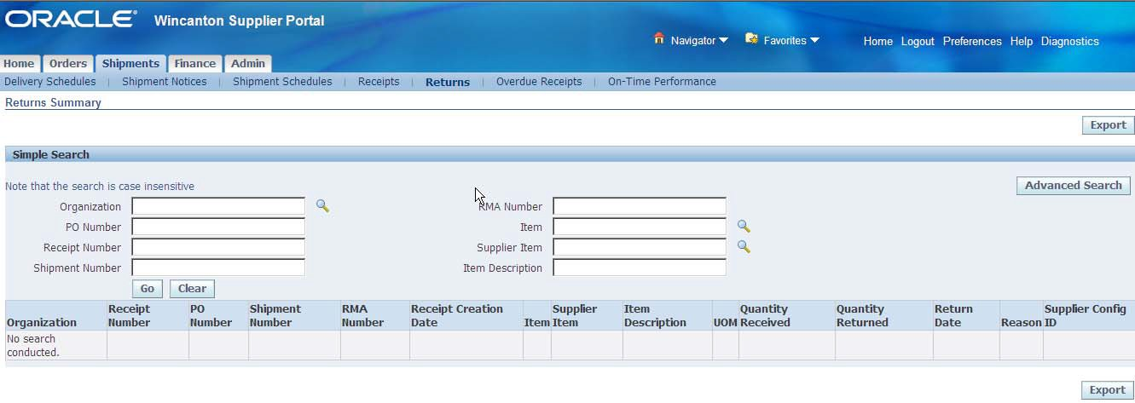

View Returns

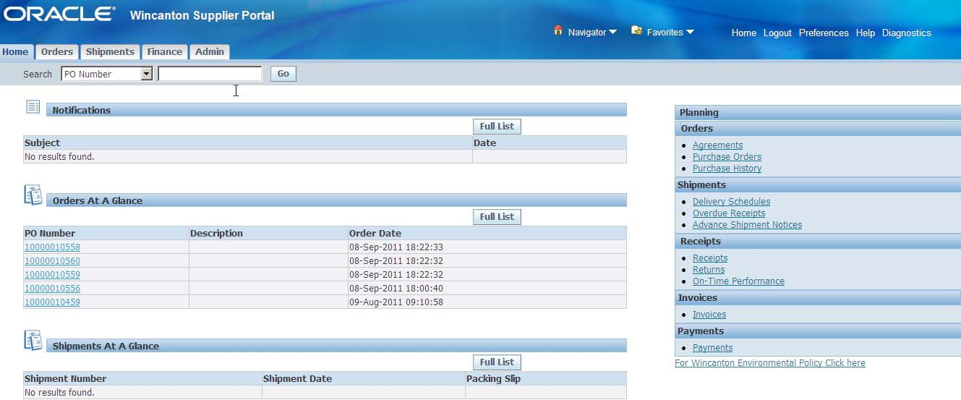
The Returns Summary web page allows you to view return history including the reason goods were returned by Wincanton. This will allow you to ensure that credit notes correspond to returns made (in the same way as an invoice). The search summary results include basic information along with details about the return, such as quantities and a reason for the return. Click on the Receipt Number and PO Number hyperlinks to view additional details.

Step | Action
1. | From the iSupplier Homepage, From the Click

Step | Action
2. | Click

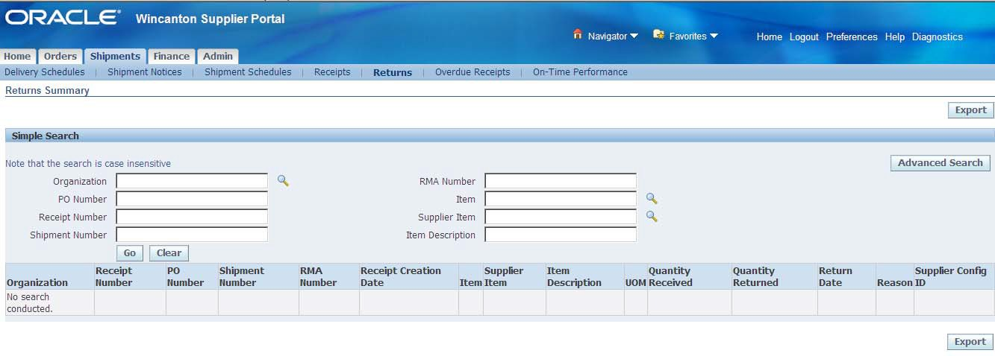
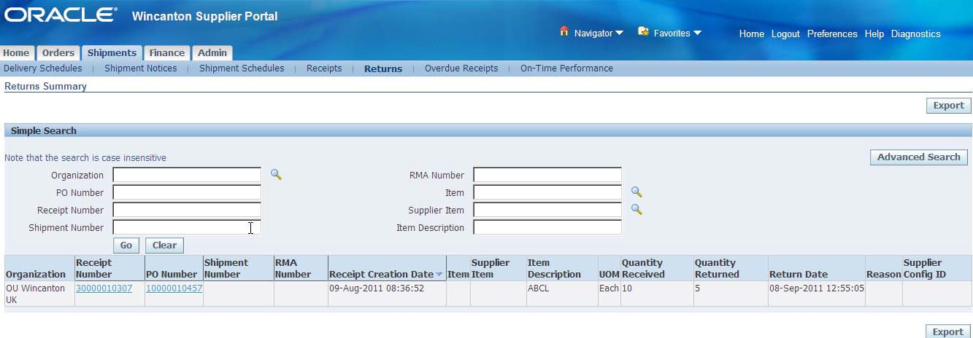
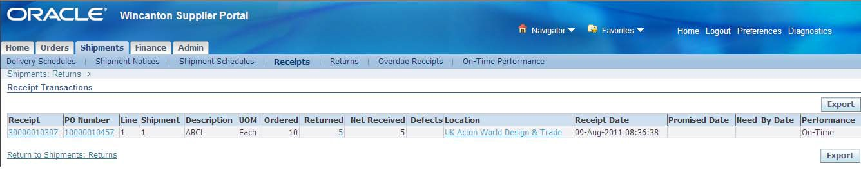

Step | Action
3. | Enter Search Criteria
4. | Click

Step | Action
5. | Select the required receipt by clicking on the Hyperlink.

Step | Action
6. | Click the Receipt Hyperlink to review full details

Step | Action
7. | Returned Goods Details can be reviewed from this page such as: Quantity Ordered  Quantity Returned Quantity Invoiced
8. | Click to return to Shipments page

Submitting Invoices

Invoices should quote valid Purchase Order numbers to enable our accounts payable team to match and process.

A PDF version of your invoices and credits notes should be emailed to the following address:
wincanton.invoices.uk@wincanton.co.uk
Only PDF Invoices can be accepted. Any other format will create a rejection
Any supporting documentation should be attached to the invoice file as one attachment on the email. Individual attachment size cannot exceed 2mb.

Any files received exceeding 2mb will create a rejection
Multiple invoices can be emailed together (in separate PDF’s), providing the email size does not exceed 20mb

Statements can be emailed to the following address:
Wincanton.statements.uk@wincanton.co.uk
The above email in-boxes are intended for the specific detailed documents. Please do not send any other documentation to these addresses.

Postal invoices should be sent to the following address:
Purchase to Pay Team
Wincanton
Methuen Park
Chippenham
Wilts
SN14 0WT
There is a dedicated Helpdesk that can be contacted to assist with any invoice queries you have. The details are as follows:

Email Supplier.helpdesk@wincanton-services.com
Telephone 0844 736 2412 (UK)
Open 8:30am to 5:00pm Monday to Friday (excluding bank holidays)

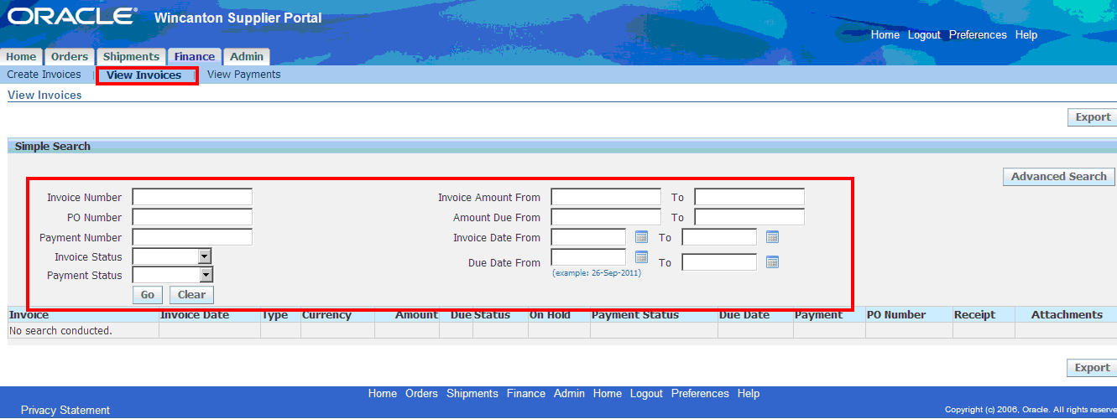

Invoicing and Payments

The Finance tab allows you to view invoice and payment information and status.

Key topics:
  - How to view Invoices
  - How to view Payments

After login, if you have been assigned more than one responsibility, select iSupplier Portal Full Access Win UK in the Applications Home Page. If only one access level is assigned, the iSupplier Portal Home tab will be shown immediately.

View Invoices
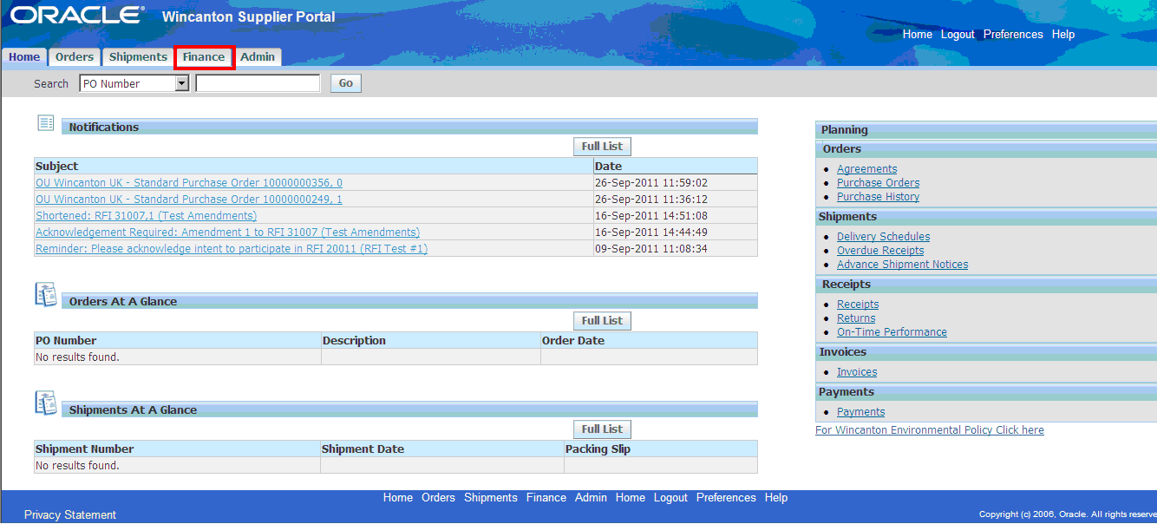
To view your list of invoices:

Step | Action
1. | Click | tab

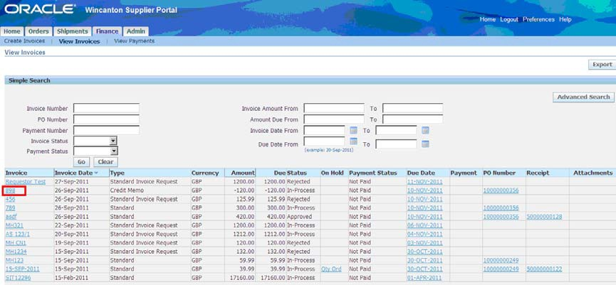
Step | Action
2. | Click sub-tab
3. | Populate search criteria  A “%” sign can be used as a wildcard to show all the invoices listed for your company. You also can enter specific information to look up a particular invoice.
4. | Click button to access invoice information

Step | Action
5. | View and access the invoice information by clicking on the specific Invoice hyperlink or view and access the specific invoice information by clicking on the PO Number, Receipts or Attachment hyperlinks.
6. | If all invoices had been requested, you can click on ‘raised’ column headers to sort the details into ascending or descending order.
7. | There are hyperlinks in the Invoice column; the PO Number column and the Receipt column Click on any hyperlink for more information.
8. | Hyperlinks can also be shown in the On Hold column and the Payment column that contain additional information.

A

B

C

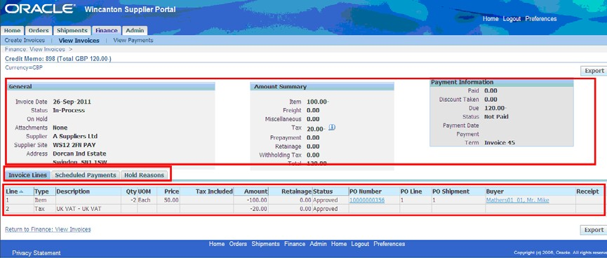
Invoice Details
- Header section: View invoice related information under General, Amount Summary, and Payment Information.

- Sub tabs: View Invoice Lines details, Scheduled Payments or Hold Reasons related to the invoice.
- Invoice Line sub tab: See line details, including PO Number, Receipt Number, Quantity, Price, Amount and Buyer.

View Payments
View and access payment information by clicking on the specific Payment hyperlink. Alternatively, view and access specific payment information by clicking on the PO Number, or Invoice hyperlinks.

To view your list of payments:

Step | Action
1. | Click

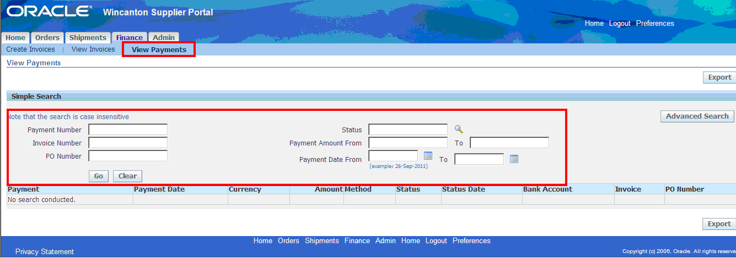
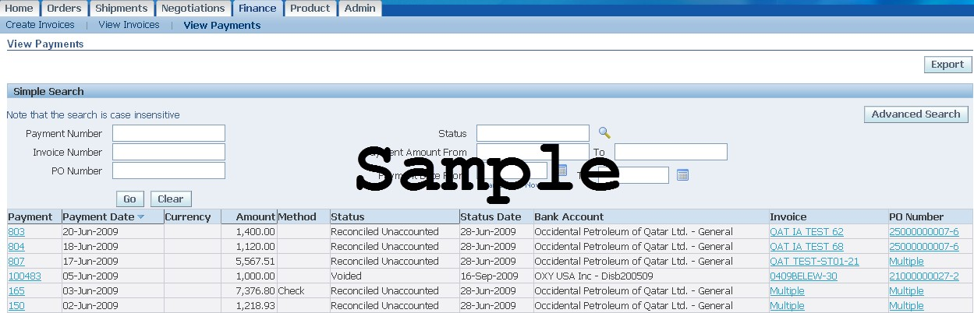

Step | Action
2. | Click
3. | Enter Search Criteria
4. | Click

Step | Action
5. | There are hyperlinks in the Payment, Invoice and PO columns. Click on any hyperlink for more information.
6. | Note: If the hyperlink in the invoice and PO Number columns read MULTIPLE, it indicates that the payment covers more than one invoice.
7. | Click on the desired Payment Number Hyperlink to display the payment details

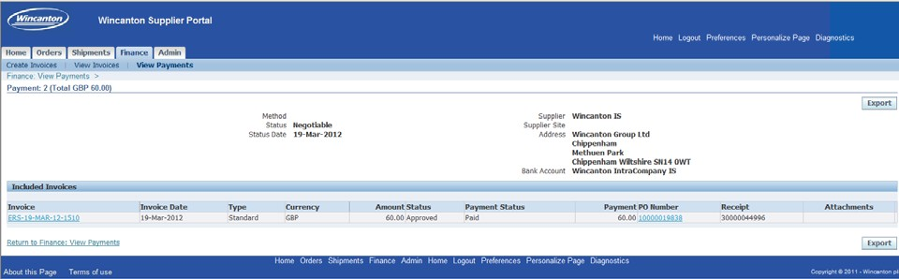

Step | Action
8. | Click on the Invoice number Hyperlink to view the Invoice details.

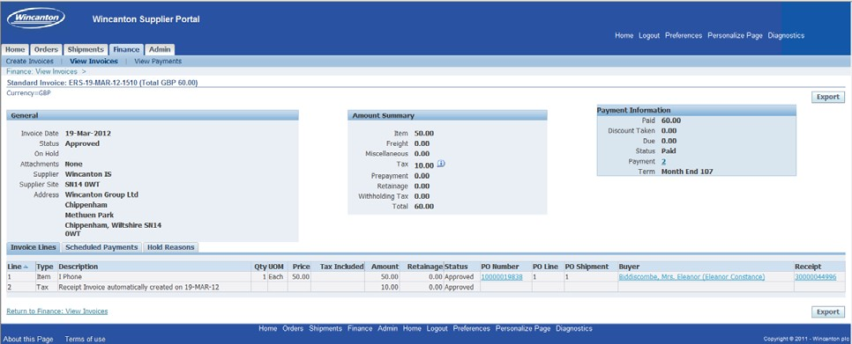

If you have any invoice queries you can contact the Supplier Help Desk which is an outsourced Accenture function based in India and can be contacted by:

Email: Supplier.helpdesk@wincanton-services.com

Telephone 0844 736 2412 (UK) or +44 (0)1249 710548 (international)

