The Wincanton Supplier Trading Process

Detailed Guidance Notes –
PO Transactions

Detailed Guidance Notes – PO Transactions

Introduction

Wincanton operates standardised back office procedures to deliver process consistency and efficiency. It is critical that Suppliers adopt these ways of working to trade effectively with Wincanton and to facilitate timely payments.

The centralised model is designed to achieve the following:

  - A single point of contact for payment queries and invoices.
  - A single, clear process regardless of Wincanton location.
  - Greater visibility and self service via iSupplier portal – an online portal offered free of charge by Wincanton to allow Suppliers real time access to review orders, payments and the status of invoices.

The Wincanton Purchase Order Process

  - Wincanton has a “No PO, No Pay” rule. For ANY work to be carried out for Wincanton, you must be in possession of a detailed, unique Purchase Order (PO) referring specifically to the goods or services you are delivering. If you are not provided with a PO, please request one before accepting the order or delivering any goods or services. The PO must have the correct prices, units of measure and quantities prior to any work commencing. The Wincanton site will amend the order if required, should the work change – this will generate a revised PO for you in order to carry out the revised work.

Examples of acceptable purchase orders can be found in appendix 1.

All payments will be made against this order ONLY.

Any mismatches, errors or missing information will hold up payment, so please ensure that you have an accurate PO or request a necessary PO amendment if it is not - in advance of commencing work and ALWAYS before invoicing. The person requesting the goods or services should be able to help with any queries you may have.

If you are a supplier to our Pullman Fleet Services business, please note that the authorisation procedures contained within appendix 3.

  - For sub-contract hauliers supplying the Wincanton Containers or Construction business or used on Wincanton’s Transport Management System “Freighter”, in some instances the purchase order may be the ticket, load or confirmation number issued to you (see appendix 1 for examples).

  - Wincanton operates a three-way match control system (PO/Receipt/Invoice). Therefore, the PO must be receipted by the site confirming the delivery of goods or services, quantity and price. The invoice must match the details held on the PO and receipt.

2.4. All purchase orders will be issued referencing either the Wincanton standard terms and conditions of purchase or, where relevant, a specific supply agreement which has been agreed between our two companies. All purchases will be made under these terms referenced on the order.

The Wincanton Invoicing & Payment Process

  - Payments will only be made against a valid purchase order, approved and receipted by Wincanton allowing Wincanton to identify the relevant site and cost owner for approval.

  - Where paid by Direct Debit, this must be clearly indicated on your invoice with the words “Paid by Direct Debit”. In addition, Direct Debit invoices and remittance advice must be submitted at least 10 days in advance of taking payment. Failure to meet this legislative requirement will result in a review of the Supplier Direct Debit mandate.

  - Credit notes must quote the correct associated invoice number and purchase order number. If not directly linked to an invoice; the relevant Wincanton contact, address and ideally profit centre should be provided.

  - All invoices should be sent in PDF format by email to the invoice address per section 5.

Any supporting documentation should be attached to the invoice file as one attachment on the email. Individual attachment size cannot exceed 2mb.

Any files received exceeding 2mb will create a rejection

Multiple invoices can be emailed together (in separate PDF’s), providing the email size does not exceed 20mb

3.5. Payment queries should be directed to the Wincanton AP Helpdesk. See section 5 for contact details.

  - You can access PO status, invoice status and payment values through the Wincanton Supplier Portal. This is a free resource provided by Wincanton to allow our Suppliers real time access to their account on the Wincanton purchase ledger system. The Supplier portal should be setup as part of the account creation process, however if you do not have access or require move users to be setup, please contact the Supplier Helpdesk who will be able to process the request for you.

  - The Proof of Delivery must be sent to the local Wincanton site to which goods or services are supplied.

  - Remittances will be sent by email when payment is due to be made.

  - Statements can be emailed to the statement address per section 5

  - Self-Bill - should you be a supplier operating self-bill with Wincanton you will receive a PO when the work is allocated for reference only. As you will not be invoicing there is no need to quote the PO on an invoice. Self-Bill invoices will then be issued by email to suppliers once approval has been undertaken.

Appendix 2 gives an example of a self-bill invoice.

Account Administration

  - As well as accessing payment information you will be able to use the Supplier Portal to:

- View orders
- View invoices

  - To amend your company details on the Wincanton system you should speak to your site or procurement contact dependent upon whether it is a local or national / preferred supplier arrangement.

  - To ensure master data is appropriately controlled and secure Wincanton have a number of processes to manage account setup and change requests. Your contact will have access to the internal forms and will be able to advise what supporting information is required.

  - The Wincanton Oracle system uses a five-digit profit centre reference. Should you use Wincanton profit centres in the administration of Wincanton accounts, please request a copy from your local Wincanton contact.

  - Wincanton operates a cyclical statement of account reconciliation process for high volume supplier accounts. Suppliers are asked to provide a statement of account upon request in excel format. If suppliers wish to review their account, more frequently or as required the supplier portal offers real time access.

Wincanton Contact Details

Invoice address (UK) | Wincanton.Invoices.uk@Wincanton.co.uk
Invoice address (Ireland) | Wincanton.Invoices.ie@Wincanton.ie
Remittance advice address | Cashmanagement.ssc@Wincanton-services.com
Statements address | Wincanton.statements.uk@wincanton.co.uk
Helpdesk address | Supplier.helpdesk@wincanton-services.com
Helpdesk telephone | +44 (0) 844 736 2412

The preferred and most efficient invoicing process is by email, using the account above, however if you are unable to issue invoices electronically, then please post to:

Invoice postal address (UK) | Purchase to Pay Team  Wincanton  Methuen Park  Chippenham  Wilts  SN14 0WT
Invoice postal address (Ireland) | Wincanton  Unit 1A  Rosemount Business  Ballycoolin Road  Dublin 11  D11 A620

Appendix 1 – Approved Purchase Order Examples

Standard Purchase Order:

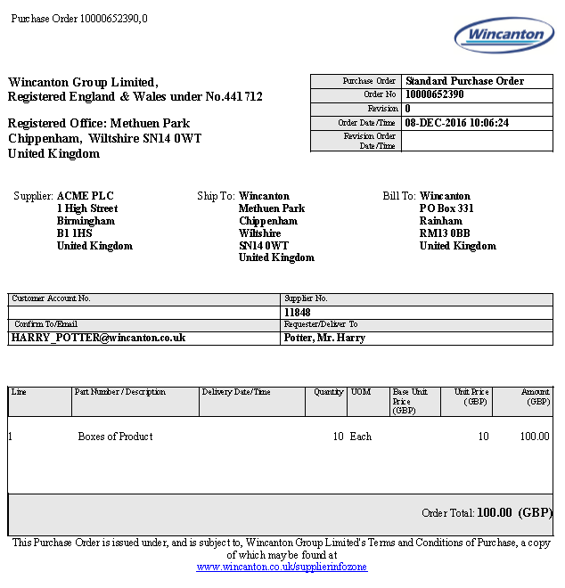

Revised Purchase Order:

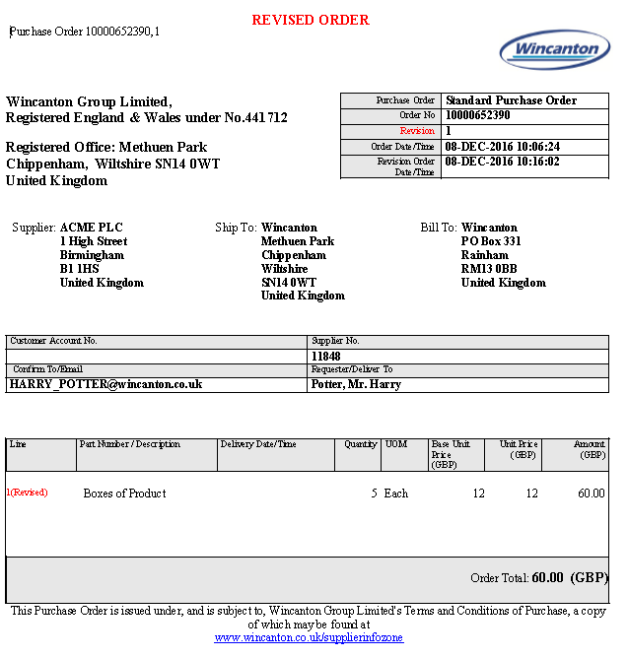

Cancelled Purchase Order:

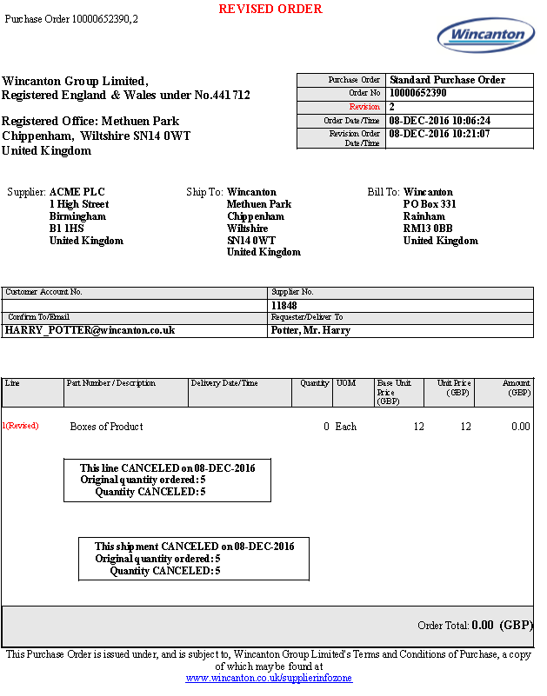

Appendix 2 – Example Self Bill

Self-Bill Invoices will be issued upon receipt of the service/goods.

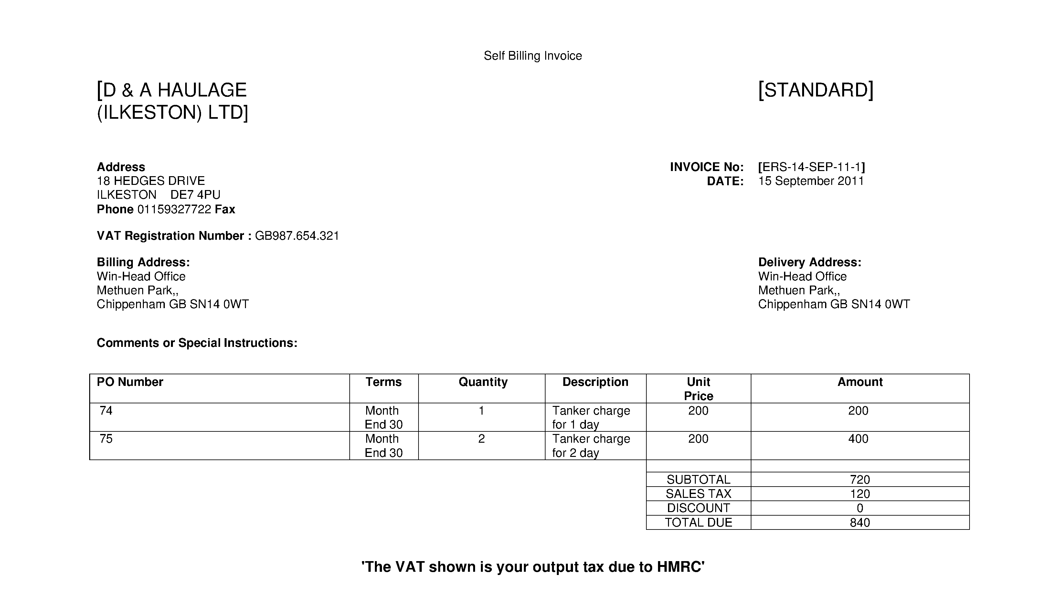

Appendix 3 – Pullman Fleet Services Authority Procedure

The following applies to all providers of vehicle parts and maintenance to our Pullman Fleet Services business.

Expenditure authority must be obtained from the Customer Service Centre (CSC) to cover all vehicle repairs or servicing carried out on Pullman Fleet Services and Wincanton managed/maintenance vehicles.

The core hours for Maintenance Control are Monday to Friday 06:00 to 18:00. Authorisation outside of the core hours must be obtained the next working day before 10:00am or for emergencies you can call our 24/7 365 Incident Support Team.
The following information will be required to obtain an authorisation number:

    - Vehicle Registration Number
    - Odometer/Hub meter reading if applicable
    - Full details of work required
    - Estimated cost
    - Defect number

Scheduled Safety Inspection (PMI) and/or MOT

A safety inspection planner is provided for each Operator and Repairer to reflect the Operator’s License constraints; this gives the Repairer authority to carry out the approved vehicle safety inspection which must cover all points highlighted in the relevant Vehicle Inspection Manual.

The repairer must liaise with the Operator to ensure that a mutually convenient date and time is agreed for the safety inspection to be carried out.

A full list of vehicle defects found on the PMI must be recorded on the service sheet and checked by the Workshop Supervisor or Manager with any serviceable defects signed off accordingly. Any defects which require immediate attention must be highlighted and the likely cost of repair must be estimated to give parts and labour breakdown.

Authority must now be gained from Wincanton / Pullman Fleet Services in accordance with the following procedure and at the same time the type of service due can be agreed and costed.

Contract | Example  Final Order Format | Estimated total Cost | Rule for request | Telephone Number | Email
Wincanton Contracts | 17CMC12345678  3 Alpha + up to 5 Numeric | <250  >250 | Email Phone | 0844 693 2742 | cmc@wincanton.co.uk
Pullman Contract Hire | 17GCH12345678  3 Alpha + up to 5 Numeric | <100  >100 | Email Phone | 0844 693 2743 | Contract.hire@pullmanfleet.co.uk
Pullman R & M | 11DPT12345601  2 numeric 3 Alpha 8 numeric | <250  >250 | Email Phone | 0844 693 2744 | r&m@pullmanfleet.co.uk
Pullman 24/7 Assist | 11DPT12345601  2 numeric 3 Alpha 8 numeric | >250 | Phone | 0844 693 2741 | 24-7.assistadmin@pullmanfleet.co.uk

The CSC will validate the request and if repairs are approved will issue a final order number to the agreed value which must be quoted on the relevant invoice and related documentation. If further repairs are found to be required these must be immediately estimated and agreed with the CSC by telephone.

Repairs not updated and any further work carried out without CSC permission will be rejected and under no circumstances will the order value be increased.

Defects/Breakdown (non scheduled repairs)

All defects must be covered by a written defect report.

Inspection of the reported defect should take place and any work found must be estimated and authorisation gained from the CSC as per the contact table above.

All displaced parts must be held for inspection until authorisation to dispose is received from CSC.

On completion of the work a detailed proforma must be sent on email along with all other relevant documents within 48 hours for validation, invoices will not be paid without them.

All repairs to vehicles will be authorised by a Technical Service Controller and periodically audited by a Contract Manager or Fleet Engineer.

If this procedure is adhered to the number of phone calls and the amount of time spent “updating” costs will be greatly reduced.

If you require further information regarding this matter, please contact your Contract Manager/Fleet Engineer.

